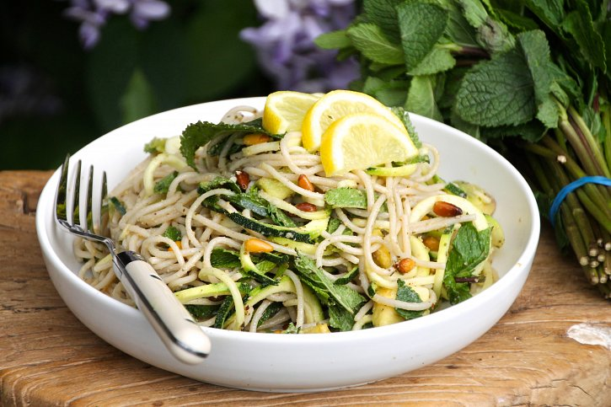

MINT & LEMON COURGETTI SPAGHETTI!

**20 June 2015**

**I love my salads and I love my pasta, so clearly a fusion of the two will be something I can’t ever get enough of! This combination is absolutely divine - light, summery, tangy and comforting. The combination of the courgetti and brown rice spaghetti gives you great textures, along with a crunch from the toasted pine-nuts and a creamy mouthful of avocado. I love making big batches of this dish, as it stores really well and marinates in all the flavour, making it even more delicious the next day. This has become my summer staple, and after you try it I’m pretty sure it will become yours too!**

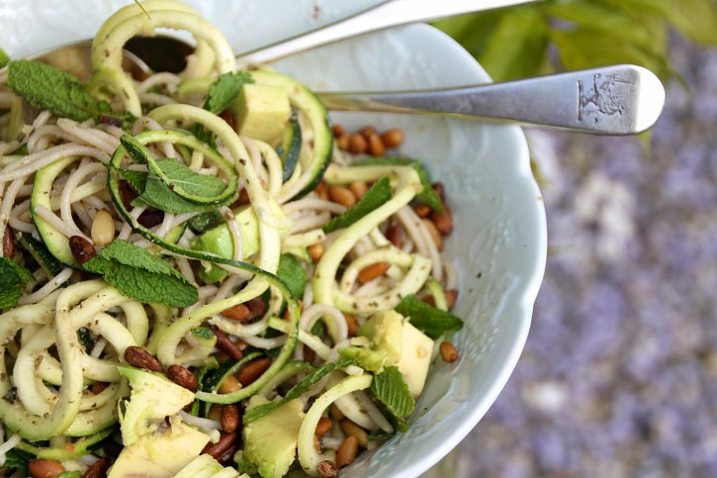

INGREDIENTS:

**Serves 1**

**2 serving brown rice spaghetti**

**2 large courgette**

**1 avocado**

**a handful of pine-nuts**

**a large handful of mint, minced**

**Juice 1 lemon**

**2 tablespoon of olive**

**a generous pinch of salt**

METHOD:

**Start by cooking the pasta, as directed on the brands packaging. Once done, drain and rinse well under cold water until the pasta is room temperature. Make sure it drains off all the water.**

**Meanwhile using a spiralizer spiralize the courgette. If you don’t have a spiralizer you can use a pealer to create long strips.**

**Roast the pine-nuts in an over for 5 minutes at 180 degrees celsius, checking to make sure they don’t burn!**

**Slice the avocado into cubes.**

**To compile add the pasta, courgette, avocado and mint to a bowl.Pour on the lemon juice, olive oil and a pinch of salt - toss well. To serve scatter with the toasted pine-nuts!**

**- See more at: http://www.naturallysassy.co.uk/recipes/mint-lemon-courgetti-spaghetti#sthash.1tbFaufH.dpuf**